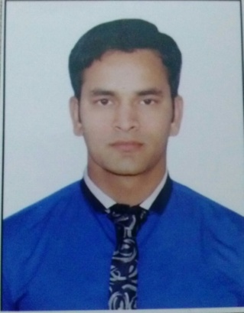

AMIT KAINTURA
Qtr/No- 969, sector-6, R. K. Puram
New Delhi-110022. ( INDIA )
M: + 91 8800799789
E: amikain07@gmail.com
hoto

PROFILE

I have hands on experience in the Hospitality industry and a proven record of delivering consistency to a very high standard. I am quickly able to add value to any team with my friendly, confident attitude, strong work ethic. I am considerate and hardworking and am able to manage multiple priorities effectively.

Employment Experience Radission Blu Hotel Dwarka New Delhi 08Dec 2014 presently as a commi - I
Sandys cocktails & kitchen
Food and Beverage Production June 2014- to 01Dec-2014
As commi I

Radisson Blu in Dwarka, New Delhi
Food and Beverage Production February 2012- December 2013
As commi II

The coffee Bean & Tea leaf in GK.1
Food and Beverage Production October 2011-February 2012
As commi III

Duties and Responsibilities

- Assist the Sous Chef in-charge to set-up daily mise-en-place.

- Ensures and meets the hygiene standards, maintains and monitors work areas, equipment, utensils and Cold room.
- Ensures highest quality and preparation and presentation of all food items.
- Ensures that food orders are prepared efficiently and within a reasonable period of time.
- Other duties and responsibilities which might be assigned from time to time by the Exec. Chef.

CORE SKILLS

- Good communication skills, being able to develop professional relationships and interact appropriately with team members and management.
- Outstanding work ethic with a commitment in achieving individual and team goals.
- Able to work independently with minimal supervision.
- Enjoy challenges, quick learner, fun and easy going.
- Proficient user of the Microsoft Office.

QUALIFICATIONS & EDUCATION

- High school completed from C.B.S.E Board in 2007.
- Intermediatecompleted from C.B.S.E Board in 2009.
- One & Half Years Diploma in Food production from IHM (NCHMCT)

PROFESSIONAL TRAINING

Six months industrial training at Saya ji Hotel Indore.

PERSONAL DETAILS

Father’s Name : Mr. Makan Singh
Sex : Male
Date of Birth : 28th July 1990
Nationality : Indian
Marital Status : Unmarried

PERSONEL ATTRIBUTES

- Collecting coins
- Cooking
- Travelling, Listening to music

AMIT KAINTURA

